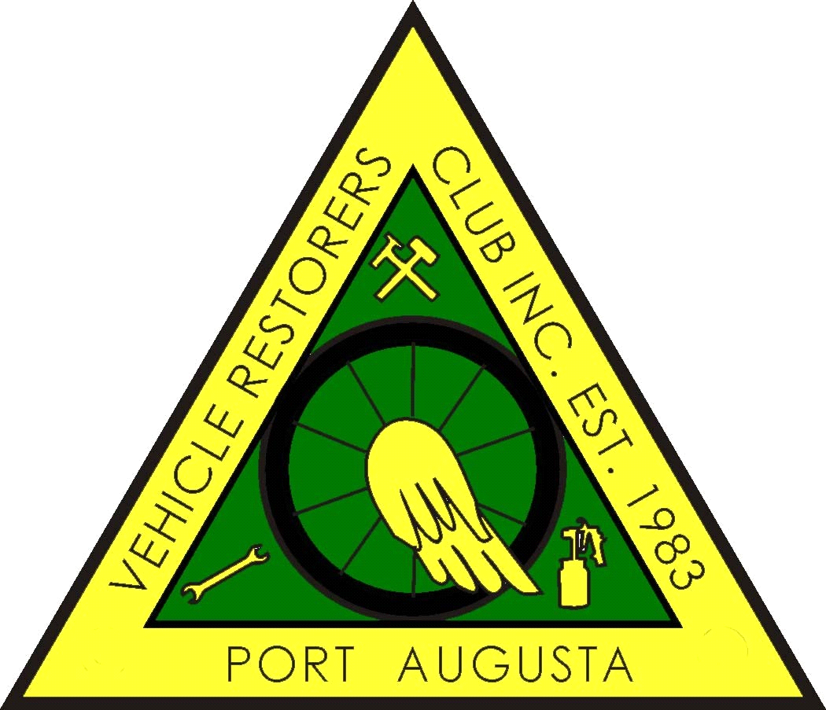

PORT AUGUSTA VEHICLE RESTORERS CLUB INC
P.O. BOX 1992, PORT AUGUSTA 5700
MEMBERSHIP FORM 2022 - 2023
Members are expected act in a manner that will not bring the Club into disrepute.
As a Member you are required to attend THREE club functions per year.
I hereby make application to RENEW or become a MEMBER of the PAVRC Inc and if accepted,
I undertake to abide by the rules of the club.
NAME/S ___________________________________________________________________
_______________________________________________________________________________
ADDRESS
_______________________________________________________________________________
_______________________________________________________________________________
POSTAL ADDRESS (If different from above)
_______________________________________________________________________________
_______________________________________________________________________________
PHONE No. _______________________ MOBILE ________________________________
EMAIL________________________@______________________________________________
BIRTHDAY DATE : _________________________ (Required for Birthday List)
MEMBERSHIP FEE: $55:00 PER PERSON FOR VEHICLE OWNERS.
FAMILY MEMBERSHIP FEE : $60:00 COVERS JOINT OWNERSHIP
VEHICLES ON CLUB REGISTRATION ONLY

MAKE. REG NO. ENGINE NO. COLOUR. YEAR LOG BOOK No:
_______________________________________________________________________________
_______________________________________________________________________________
_______________________________________________________________________________
_______________________________________________________________________________
_______________________________________________________________________________
NOMINATED BY __________________ SECONDED BY ______________________
NEW MEMBER Signature__________________________________________

OFFICE USE ONLY
RECEIPT NO. __________________________ DATE______________________________
ONLINE PAYMENT:
Please notate with your name(s) and “PAVRC Membership Fees 2020/21”
Bank: BSB No: 325 185 Account Number: 02209729
Account Name: Port Augusta Vehicle Restorers Club Inc.

