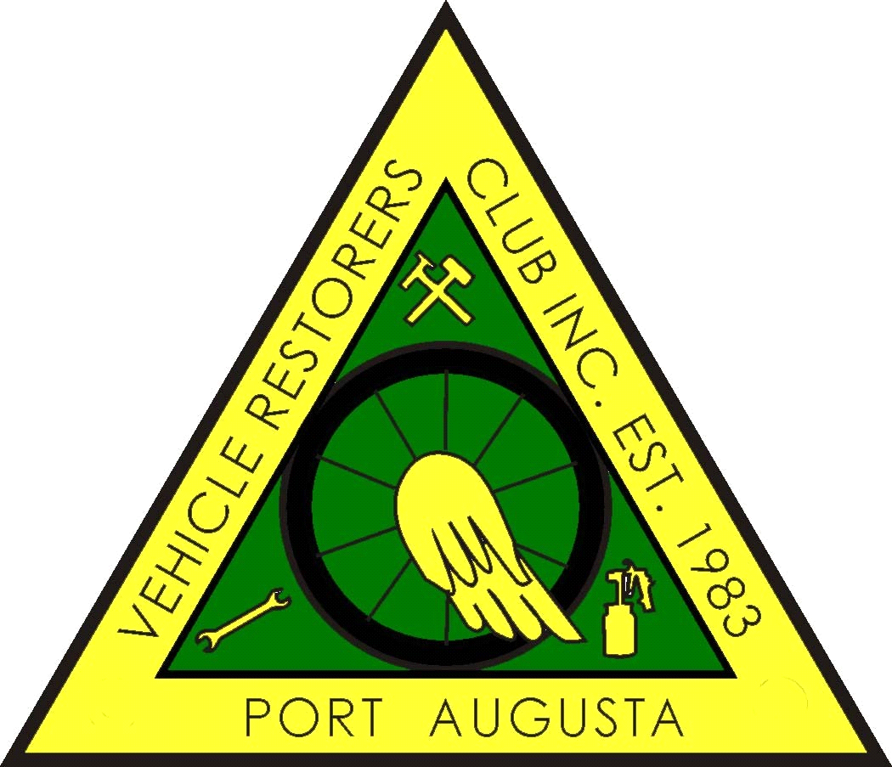

PORT AUGUSTA VEHICLE RESTORERS CLUB INC
P.O. BOX 1992, PORT AUGUSTA 5700
MEMBERSHIP FORM 2024- 2025
Members are expected act in a manner that will not bring the Club into disrepute.
I hereby make application to RENEW or become a MEMBER of the PAVRC Inc and if accepted,
I undertake to abide by the rules of the club.
NAME/S ______________________________________________________________________________
_______________________________________________________________________________
ADDRESS
__________________________________________________________________________________________
__________________________________________________________________________________________
POSTAL ADDRESS (If different from above)
__________________________________________________________________________________________
__________________________________________________________________________________________
PHONE No. _____________________________ MOBILE ________________________________________
EMAIL_____________________________@____________________________________________________
BIRTHDAY DATE : ____________________________ (Required for Birthday List)
MEMBERSHIP FEE: $60.00 PER PERSON FOR VEHICLE OWNERS
FAMILY MEMBERSHIP FEE : $65:00 COVERS JOINT OWNERSHIP
VEHICLES ON CLUB REGISTRATION ONLY
MAKE. REG NO. ENGINE NO. COLOUR. YEAR LOG BOOK No:

__________________________________________________________________________________________

NOMINATED BY _______________________________ SECONDED BY __________________________
NEW MEMBER SIGNATURE __________________________________________
OFFICE USE ONLY
RECEIPT NO. _____________________________ DATE ___________________________________
ONLINE PAYMENT:
Please notate with your name(s) and “PAVRC Membership Fees 2024/25”
Bank: BSB No: 325 185 Account Number: 02209729
Account Name: Port Augusta Vehicle Restorers Club Inc.

