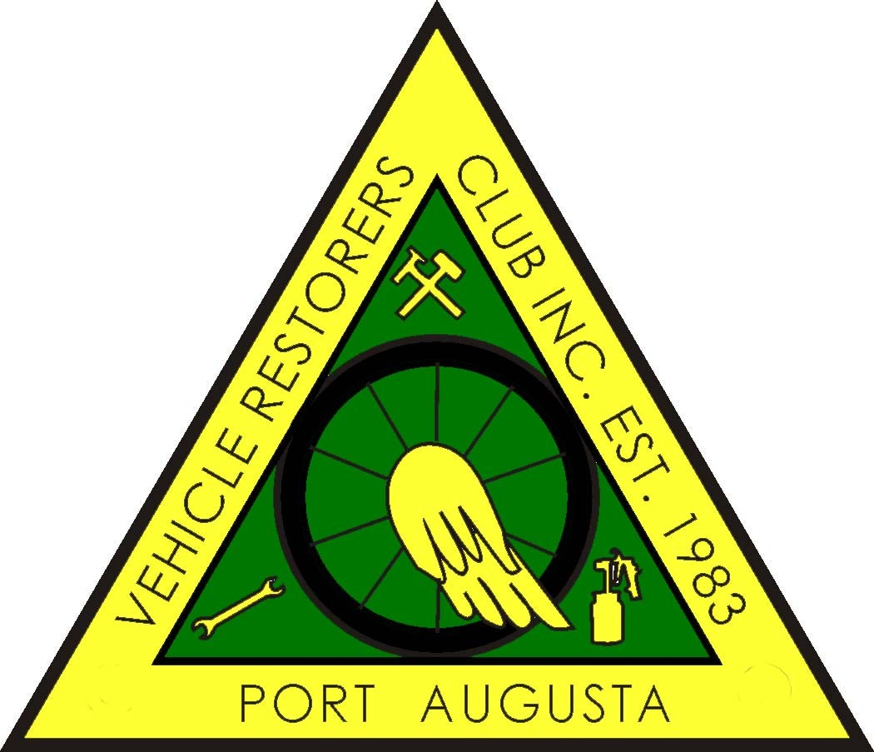

PORT AUGUSTA VEHICLE RESTORERS CLUB INC
P.O. BOX 1992, PORT AUGUSTA 5700
MEMBERSHIP FORM 2018 - 2019
Members are expected act in a manner that will not bring the Club into disrepute.
As a Member you are required to attend THREE club functions per year.
I hereby make application to RENEW or become a MEMBER of the PAVRC Inc and if accepted, I undertake to abide by the rules of the club.
NAME/S _____________________________________________________________________
_____________________________________________________________________
ADDRESS _____________________________________________________________________
_____________________________________________________________________
POSTAL ADDRESS (If different from above)
_____________________________________________________________________
_____________________________________________________________________
PHONE No. _______________________ MOBILE ____________________________________
EMAIL ________________________@ ___________________________________________
MEMBERSHIP FEE: $30:00 PER PERSON ______________________________
ASSOCIATE MEMBERSHIP FEE : $15:00 PER PERSON ___________________
(Associate Member can be child/family member (under 18years), relative or friend)
VEHICLES ON CLUB REGISTRATION ONLY

MAKE. REG NO. ENGINE NO. COLOUR. YEAR LOG BOOK No:

NEW MEMBER NOMINATED BY ______________________________________
SECONDED BY ______________________________________
NEW MEMBER Signature _________________________________
OFFICE USE ONLY
RECEIPT NO. __________________________ DATE_____________________

This form is to be returned to the Secretary after endorsement by the Treasurer.

