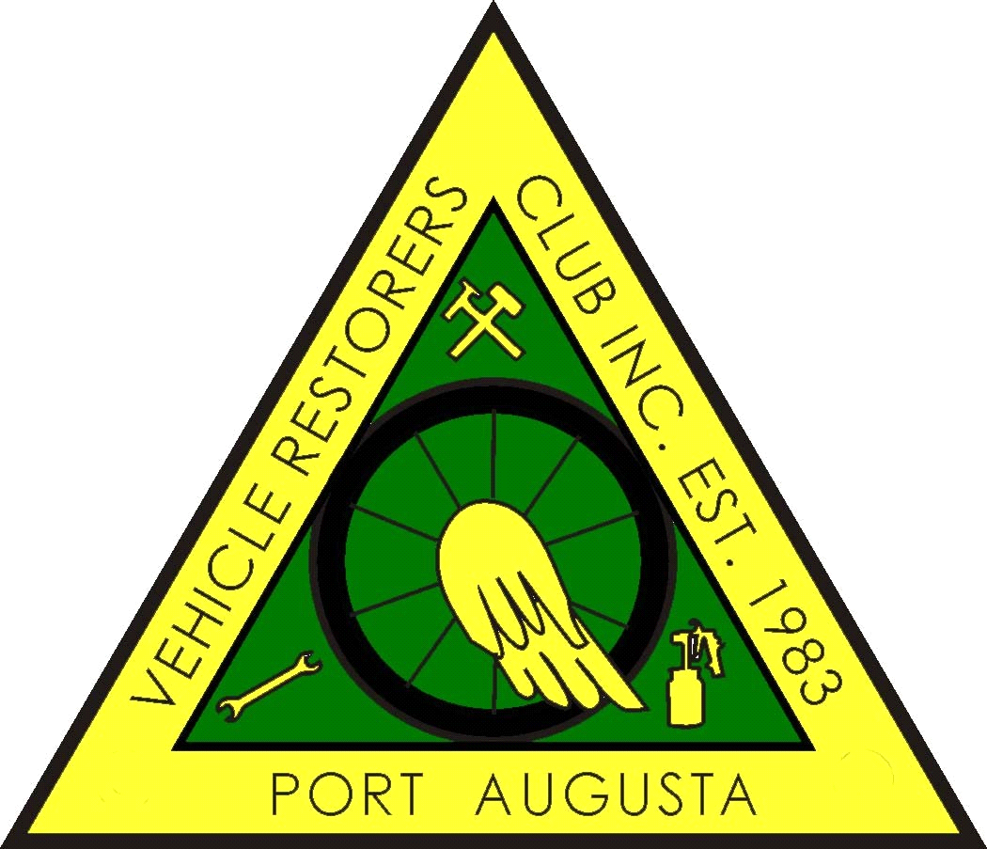

PORT AUGUSTA VEHICLE RESTORERS CLUB INC
P.O. BOX 1992, PORT AUGUSTA 5700
MEMBERSHIP FORM 2019- 2020
Members are expected act in a manner that will not bring the Club into disrepute.
As a Member you are required to attend THREE club functions per year.
I hereby make application to RENEW or become a MEMBER of the PAVRC Inc and if accepted,
I undertake to abide by the rules of the club.
NAME/S ___________________________________________________________________
_______________________________________________________________________________
ADDRESS
_______________________________________________________________________________
_______________________________________________________________________________
POSTAL ADDRESS (If different from above)
_______________________________________________________________________________
_______________________________________________________________________________
PHONE No. _______________________ MOBILE ________________________________
EMAIL________________________@_______________________________________________
MEMBERSHIP FEE: $40:00 PER PERSON FOR VEHICLE OWNERS.
FAMILY MEMBERSHIP FEE : $50:00 COVERS JOINT OWNERSHIP

VEHICLES ON CLUB REGISTRATION ONLY

MAKE. REG NO. ENGINE NO. COLOUR. YEAR LOG BOOK No:
_______________________________________________________________________________
_______________________________________________________________________________
NOMINATED BY __________________ SECONDED BY _______________________
NEW MEMBER Signature__________________________________________
OFFICE USE ONLY
RECEIPT NO. __________________________ DATE_______________________________

BANKING ONLINE: Please notate with your name(s) and “Membership Fees 2019/20”
Bank: BSB No: 325 185 Account Number: 02209729
Account Name: Port Augusta Vehicle Restorers Club Inc.

