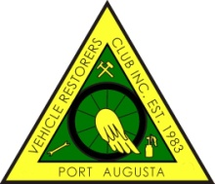

PORT AUGUSTA VEHICLE RESTORERS CLUB INC
P.O. BOX 1992, PORT AUGUSTA 5700
MEMBERSHIP FORM 2016 - 2017
As a Member you are required to attend THREE club functions per year.
I hereby make application to RENEW or become a MEMBER of the PAVRC Inc and if accepted, I undertake to abide by the rules of the club.

NAME/S _________________________________________________________
_________________________________________________________

ADDRESS _________________________________________________________
_________________________________________________________
POSTAL ADDRESS (If different from above)
_________________________________________________________
_________________________________________________________
PHONE NO. _______________________ MOBILE _______________________
EMAIL ________________________@________________________________
MEMBERSHIP FEE: $25:00 PER PERSON __________________
VEHICLES ON HISTORIC REGISTRATION ONLY

MAKE. REG NO. ENGINE NO. COLOUR. YEAR LOG BOOK No:

NEW MEMBER NOMINATED BY _____________________________________
SECONDED BY __________________________________

OFFICE USE ONLY
RECEIPT NO. __________________________ DATE _____________________

